1. Household Budget Pie Chart
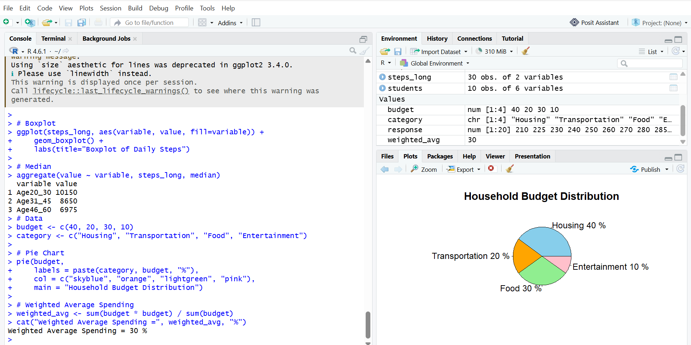

2. Grade Distribution Bar Chart
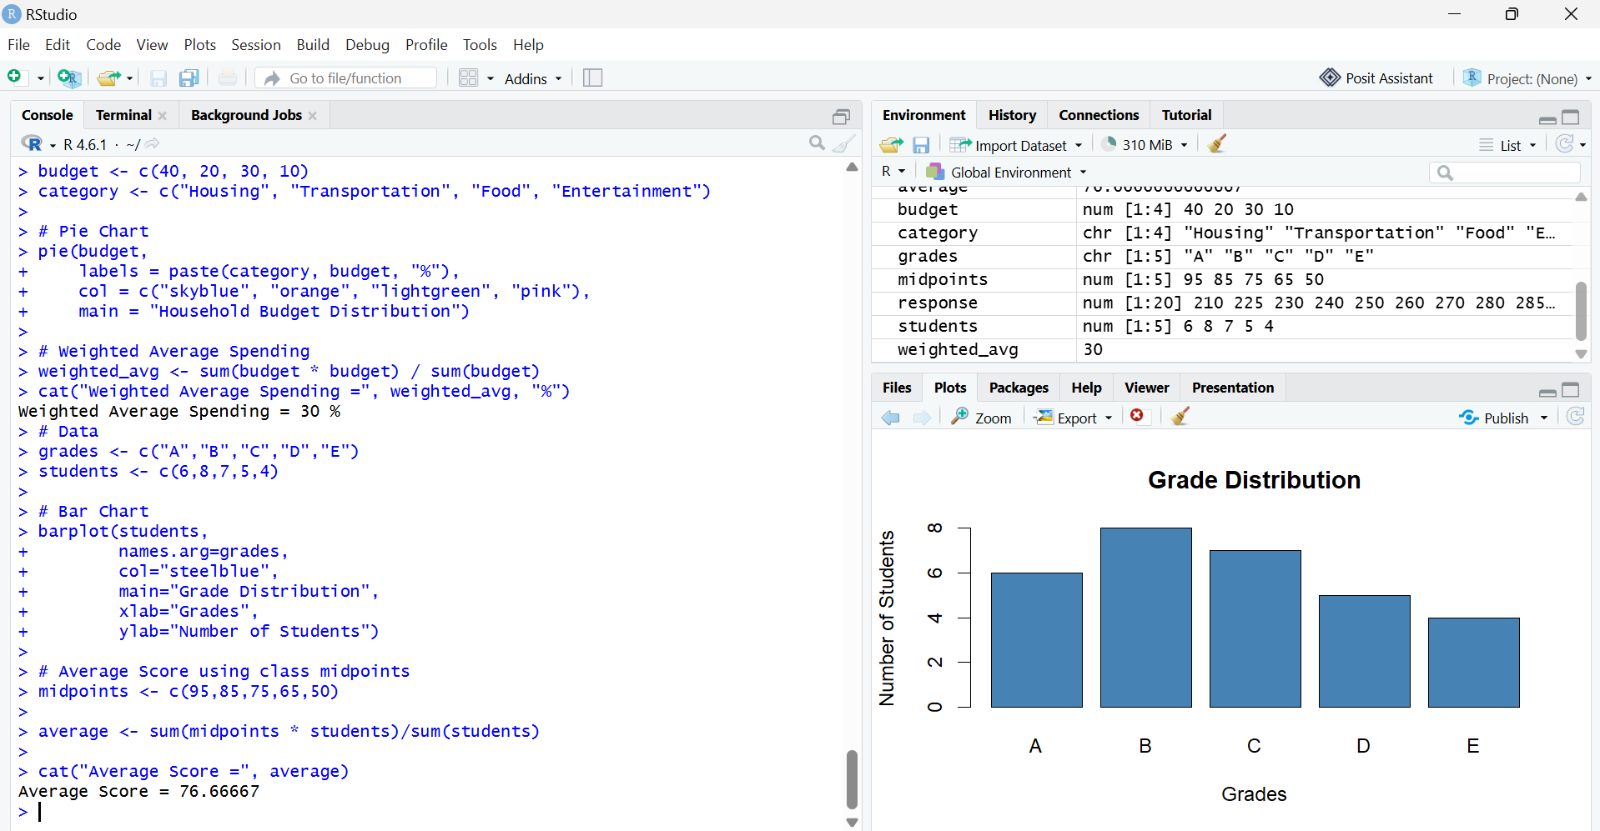

3. Favourite Fruit Bar Chart
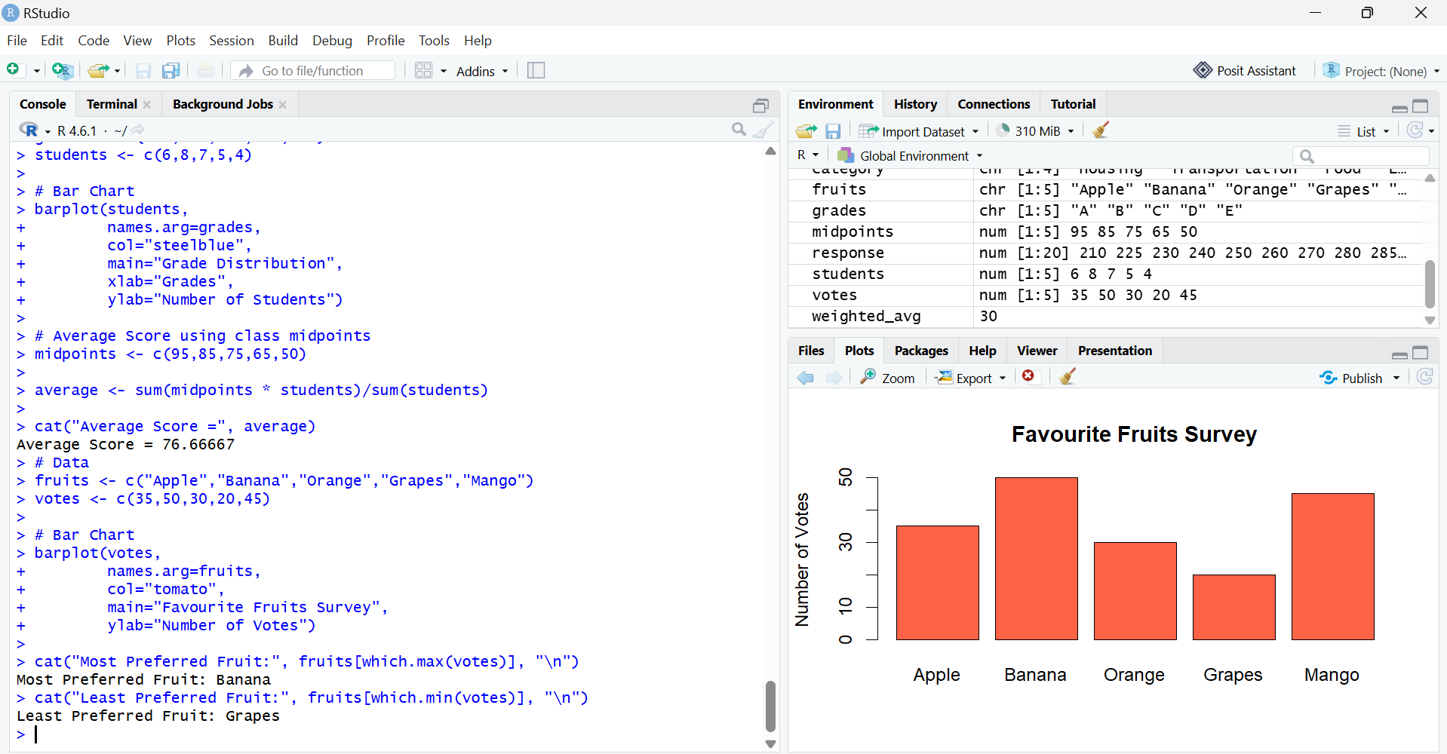

4. Employees by Department Pie Chart
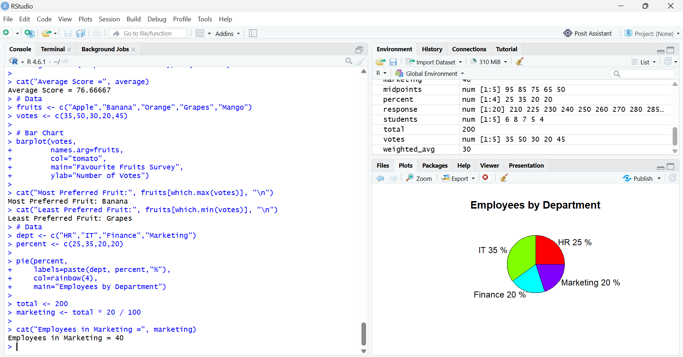

5. Weekend Activities Pie Chart
